**Specialist Mathematics Investigation 3**

**Integration By Parts & Numerical Integration**

**In Class Validation**

**Non-Calculator Section**

**No Calculators or notes allowed in the validation. Mobile phones must be switched off and in bags.**

**Name: _______________________________**

*Answer all questions in the spaces provided and provide full working to justify your answers.*

**Time allowed : 35 minutes Maximum marks = 32**

**Integration by Parts & Escalante’s Method**

Using the method of **Integration by Parts**, determine the following indefinite integrals. Take care to simplify your answers as far as possible.

**1.  [ 4 marks ]**

**2.  [ 4 marks ]**

**3.  [ 5 marks ]**

**4.  [ 6 marks ]**

Now we have seen that integrals of the form , in which f(x) can be differentiated repeatedly to become zero and g(x) can be integrated repeatedly without difficulty, the Integration by parts formula can be used.

However, if many repetitions are required, the calculations can be cumbersome.

**Jaime Escalante** came up with a way to organise the calculations that saves a great deal of work. It is called **Tabular Integration** and it is illustrated in the examples below.

Example 1 Find 

Let f(x) = x2 and g(x) = 



f(x) and its derivatives g(x) and its integrals

x2 + cos x

2x - sin x

2 + -cos x

0 -sin x

Example 2: Find 

Let f(x) = x3 and g(x) =

f(x) and its derivatives g(x) and its integrals

x3 + sin x

3x2 - -cos x

6x + -sin x

6 - cos x

0 sin x



**Part Two:** Using the method of Tabular Integration or Escalante’s Method, find the following integrals:

**5.**  **[ 4 marks ]**

**6.**  **[ 3 marks ]**

**7.**  **[ 2 marks ]**

**8.  [ 4 marks ]**

END OF SECTION

**Specialist Mathematics Investigation 3**

**Integration By Parts & Numerical Integration**

**In Class Validation**

**Calculator Assumed Section**

**No notes allowed in the validation. Mobile phones must be switched off and in bags.**

**Name: _______________________________**

*Answer all questions in the spaces provided and provide full working to justify your answers.*

**Time allowed : 25 minutes Maximum marks = 23**

**9. A**pproximate the area ,

a) using the Trapezoidal Rule with 6 strips **[ 6 marks ]**

b) using Simpson’s Rule with 6 strips **[ 5 marks ]**

**ANOTHER NUMERICAL INTEGRATION TECHNIQUE - THE MID-POINT RULE**

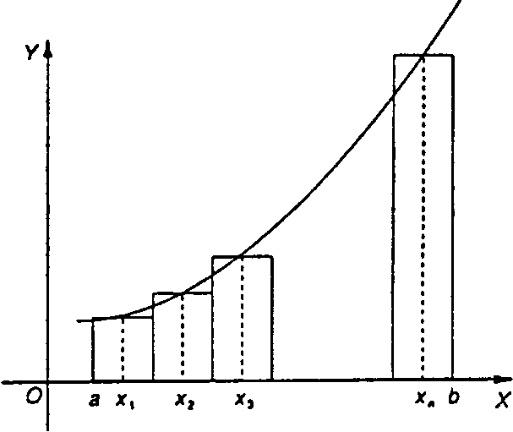Let f be a continuous function in the interval [a; b]. Divide this interval into n subdivisions, each of width

Using these subdivisions as bases, n rectangles are drawn of width w and height f(x1), f(x2), f(x3) where x1,x2, x3are the x-coordinates of the mid-point of the subdivision, as illustrated in the figure below.

A numerical method of approximating the area of the region bounded by the curve the x-axis and the ordinatesx=a andx= b is to calculate the sum of the areas of these rectangles:

Example

Use the mid-point rule to find, approximately, the area bounded by the parabola defined by , the x-axis and the lines x = 1 and x = 3, using four intervals.

The x-coordinates of the mid-points of each of the four intervals are x = 1.25, 1.75, 2.25 and 2.75 and .

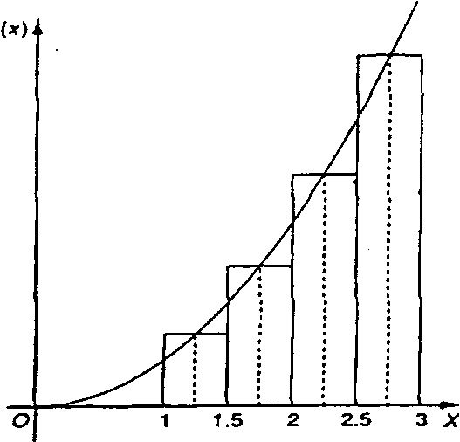

=

[f(l.25) + f (1.75) + f (2.25) + f (2.75)]

= 0.5[l.5625 + 3.0625 +5.0625 + 7.5625]

= 8.625

**9 c)** Use the mid-point rule to approximate the area  **[ 5 marks ]d)**  Why is the “area” negative ? **[ 1 marks ]**

**e)** Which approximation is closest to reality? Justify your answer. **[ 2 marks ]**

**f)** Discuss why this is the case. **[ 4 marks ]**

END OF PAPER